Phase9-Report and Dashboards:

1. Reporting Components: Patient Performance Report
2. Create the new Tabular report Then Add the Patient Name ,Patient Number ,Pateint Age ,Patient Gender(Tabular Report)

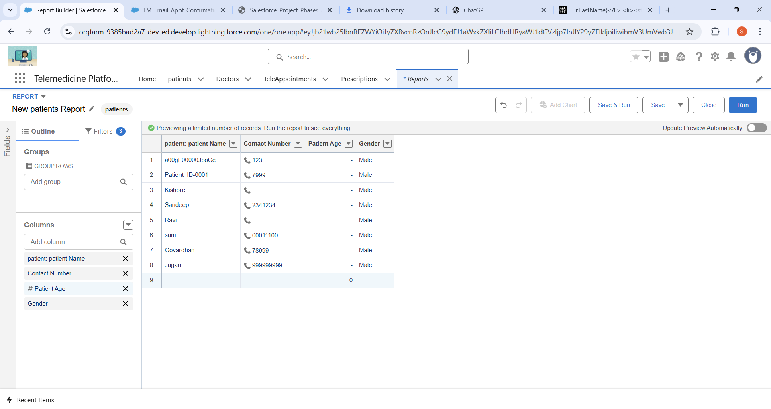

1. Create the new summary report In TeleAppointment: Teleappointment Performance Report

* Add the TeleAppointment Name for the summary report🡪group rows add Doctor, patient, Status

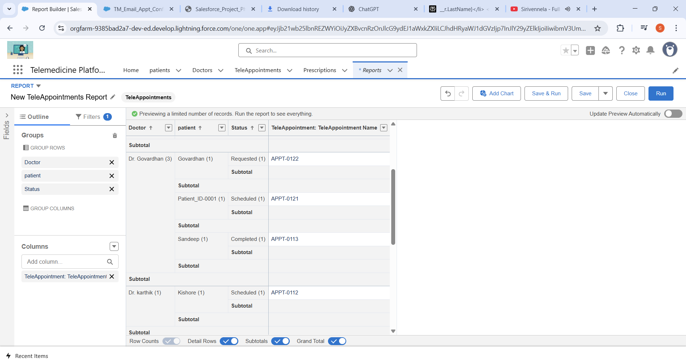

* **Successfully run and the report**

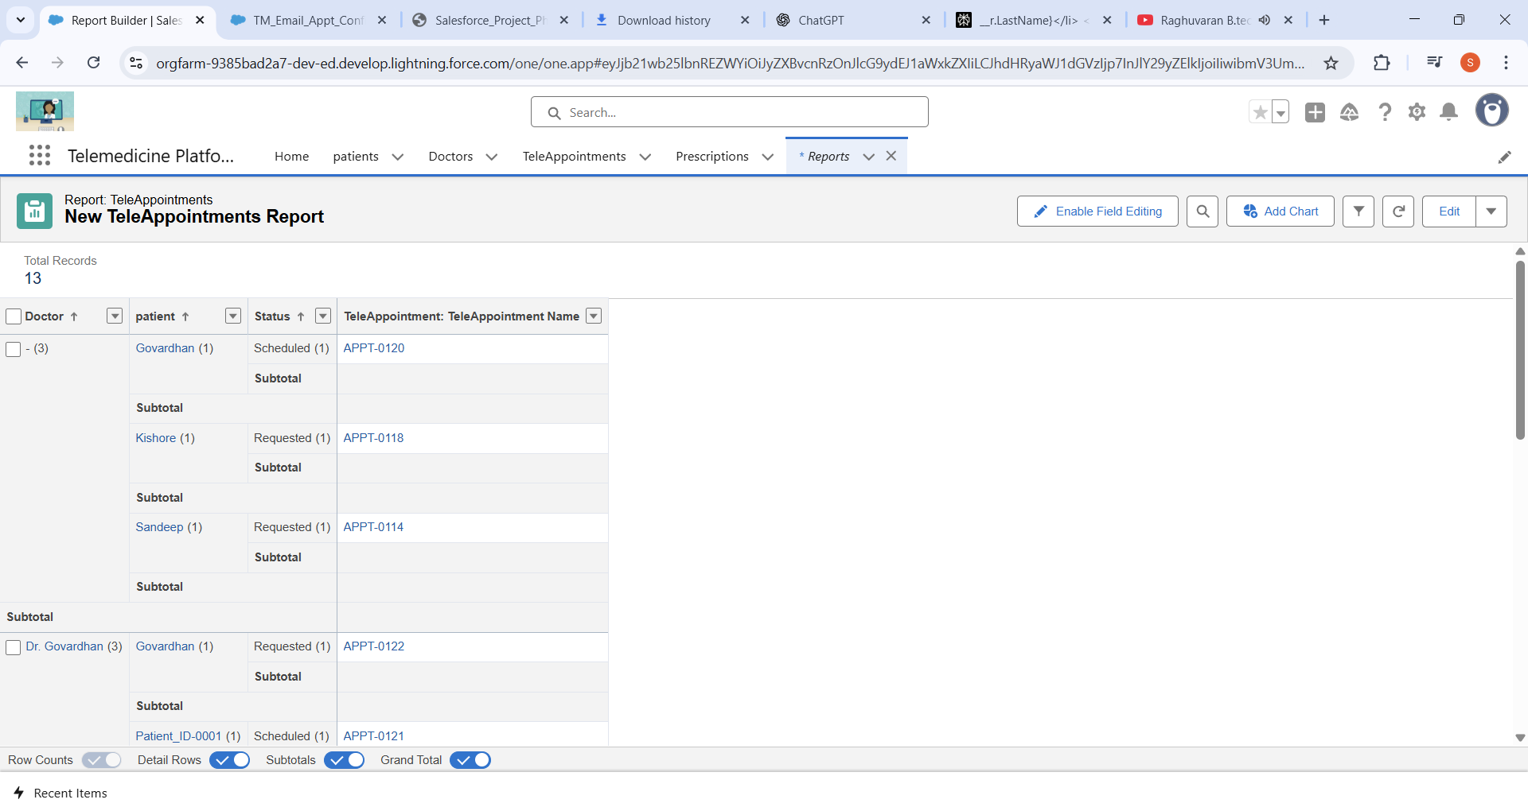

1. Create the new summary report In Doctor: Doctor Performance Report

* Add the TeleAppointment Name for the Matrix report🡪 Drag Doctor into the Group Columns area and Status into Group Rows.

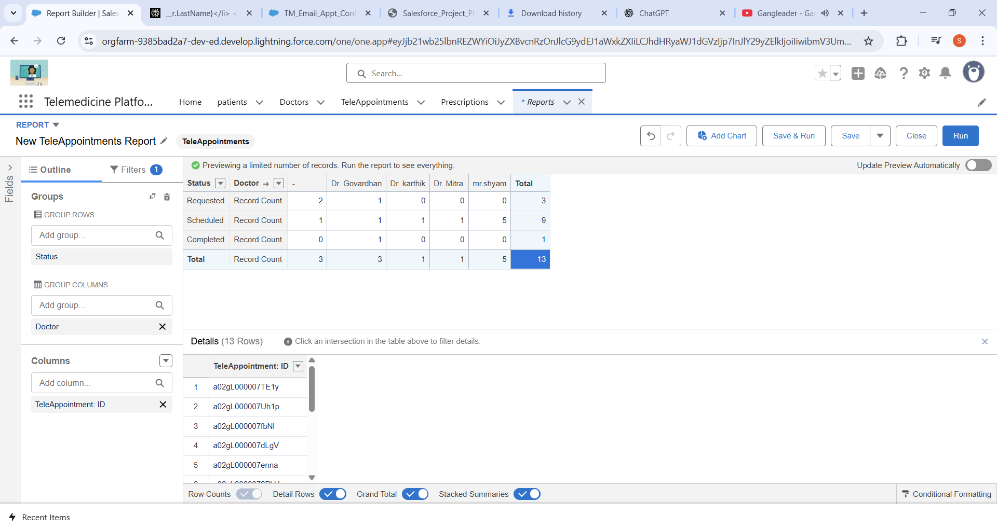

* **Successfully run the report and the total records are 13**

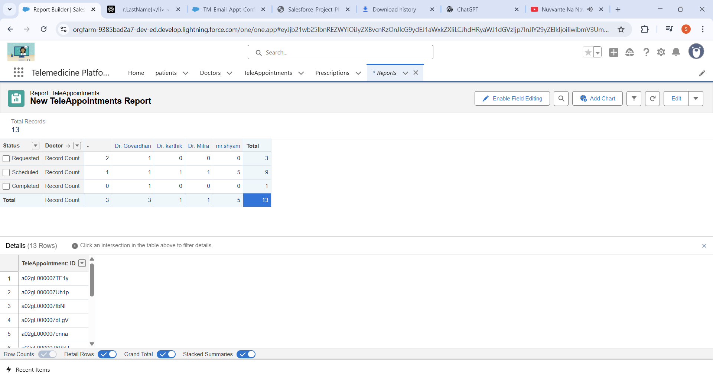

1. Telemedicine Dashboard: Dashboard of Patient

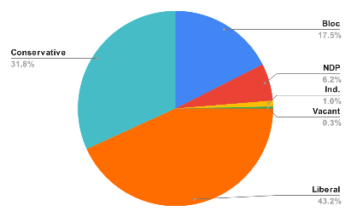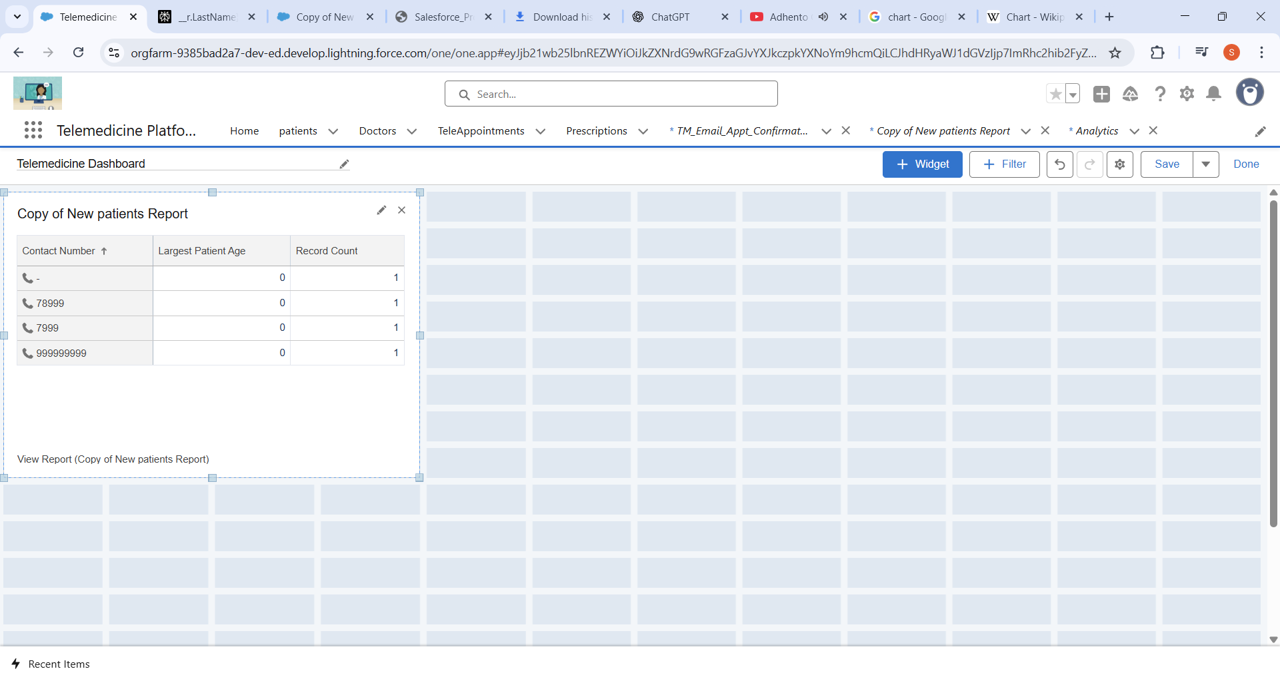

1. Click + Component, select your “Patient Demographics Report,” choose a chart type pie chart and add to the dashboard.
2. Dynamic Dashboard:

* Created the dashboard with NameExecutive Dashboard:

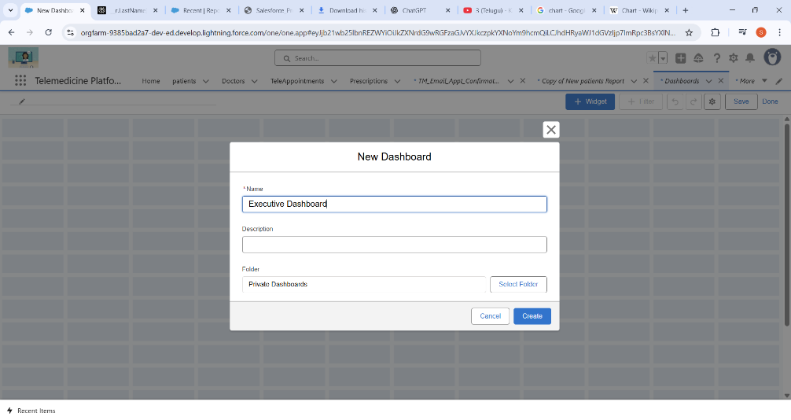

* Set the properties to the Dashboard Viewer:

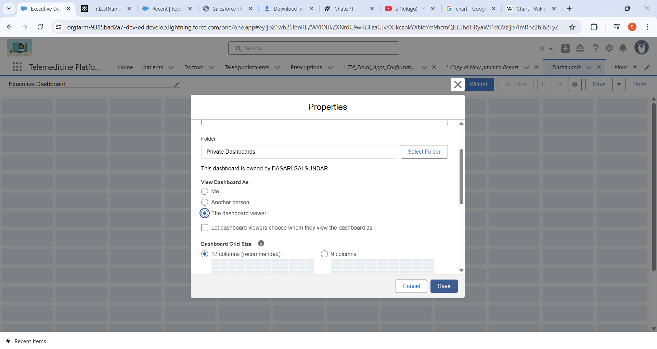

* Successfully add the Graph plot in the Dynamic Dashboard

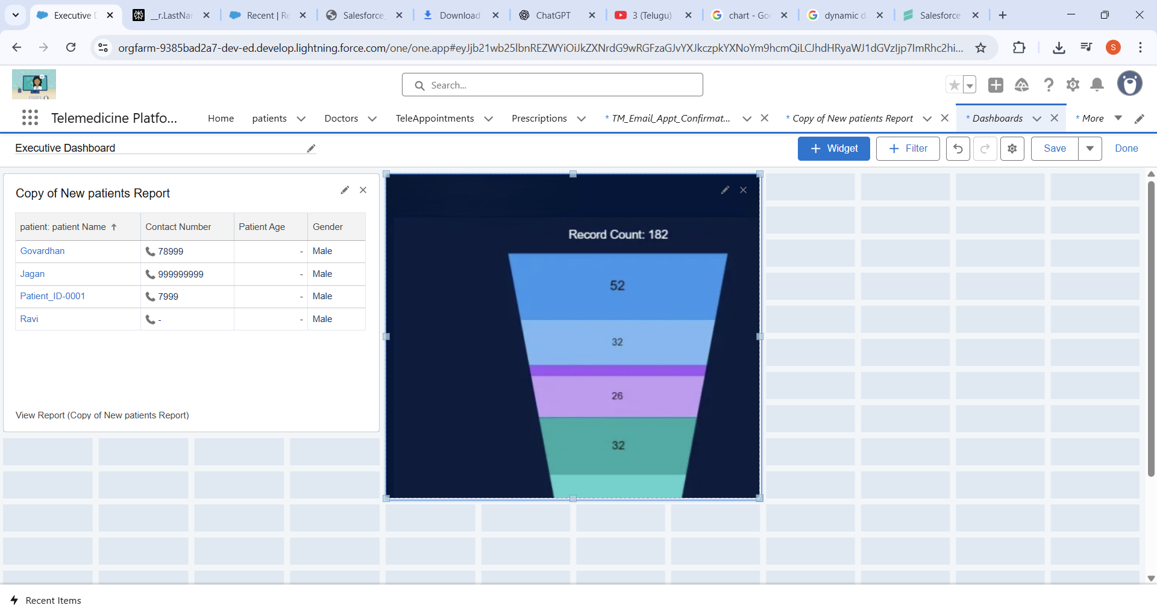

1. Sharing settings:

* For the patient and Teleappointment objects, set Default access to Private. This ensures only record owners and users above them in the role hierarchy can view or edit records by default.

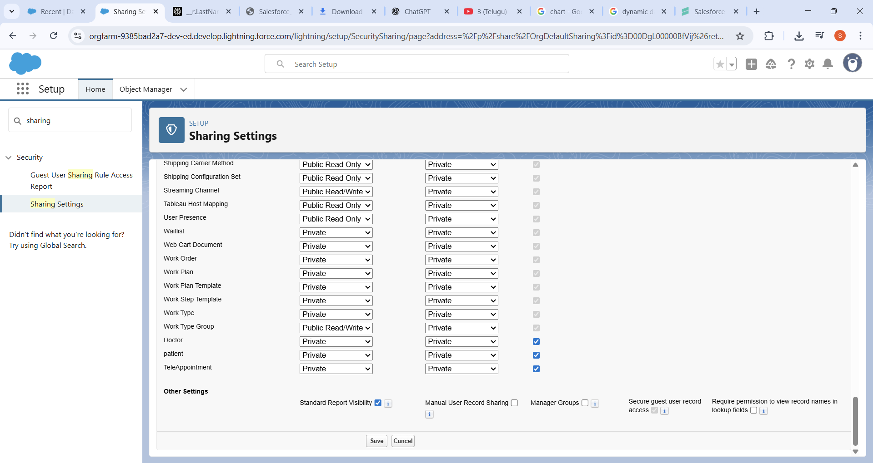

* Created the patient sharing rule: that ensure the Particular Patient assigned to the that Specialization Doctor

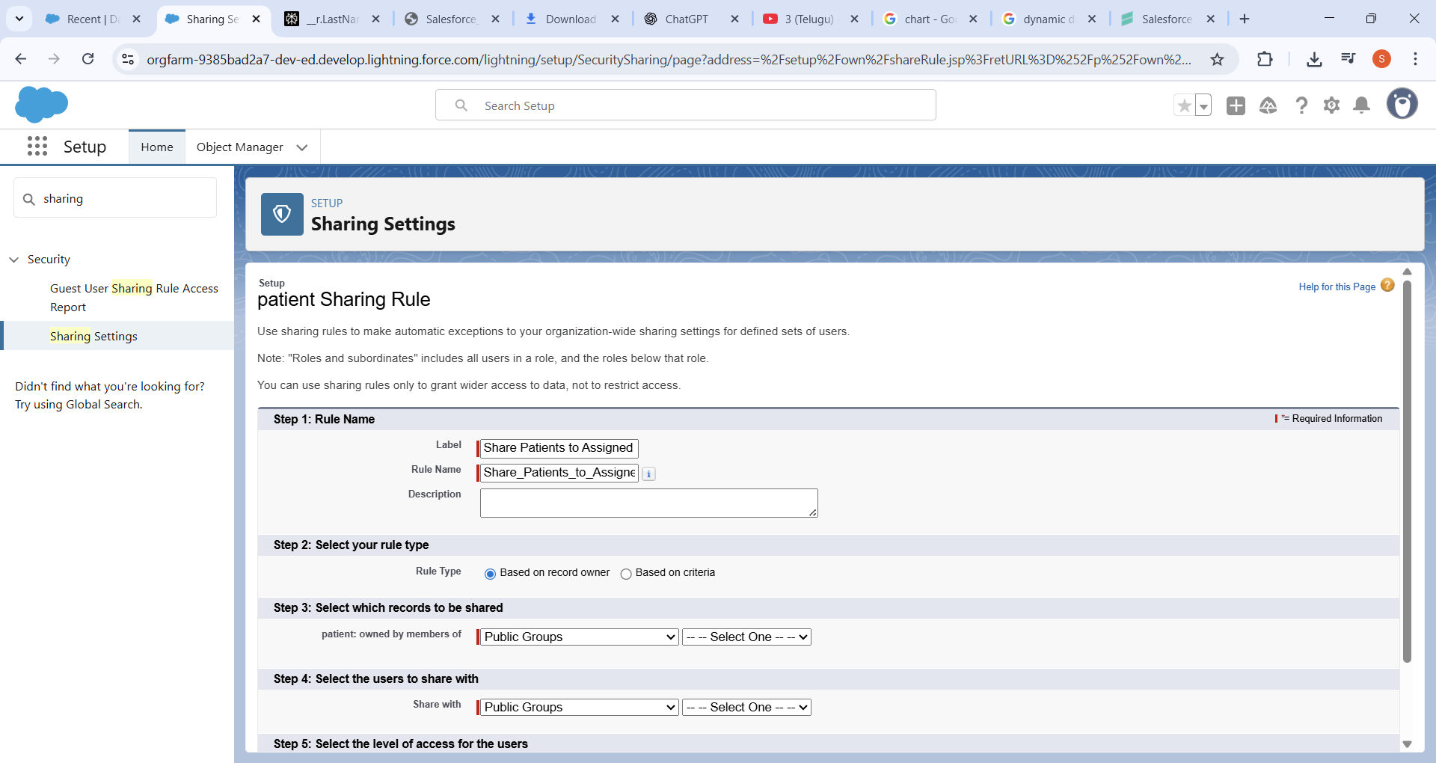

* Here the given criteria that the patient can be assigned to the only selected specialization.Patient → Assigned Doctor ≠ blank

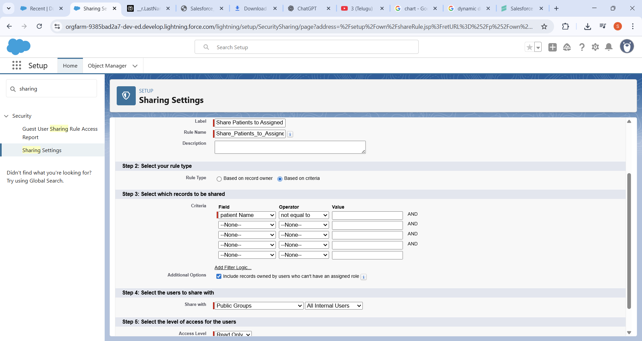

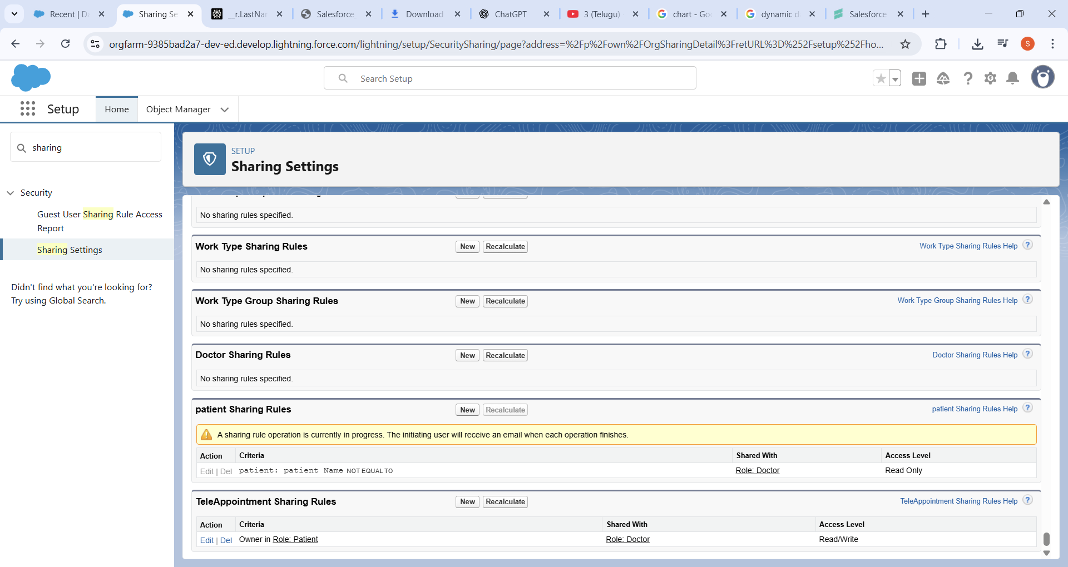

For the Patient and Appointment objects, set Default Internal Access to Private. This ensures only record owners and users above them in the role hierarchy can view or edit records by default.

1. Field Level Security:

* For profiles like Standard User or Guest User, uncheck Visible to completely hide the field.
* For profiles like Doctor or System Administrator, leave Visible checked.
* If certain profiles should see but not edit the field, check Visible and Read-Only.

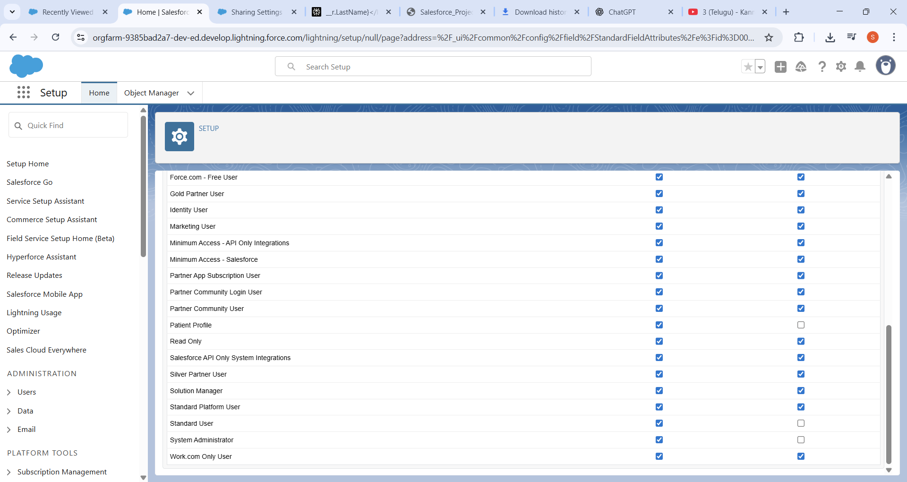

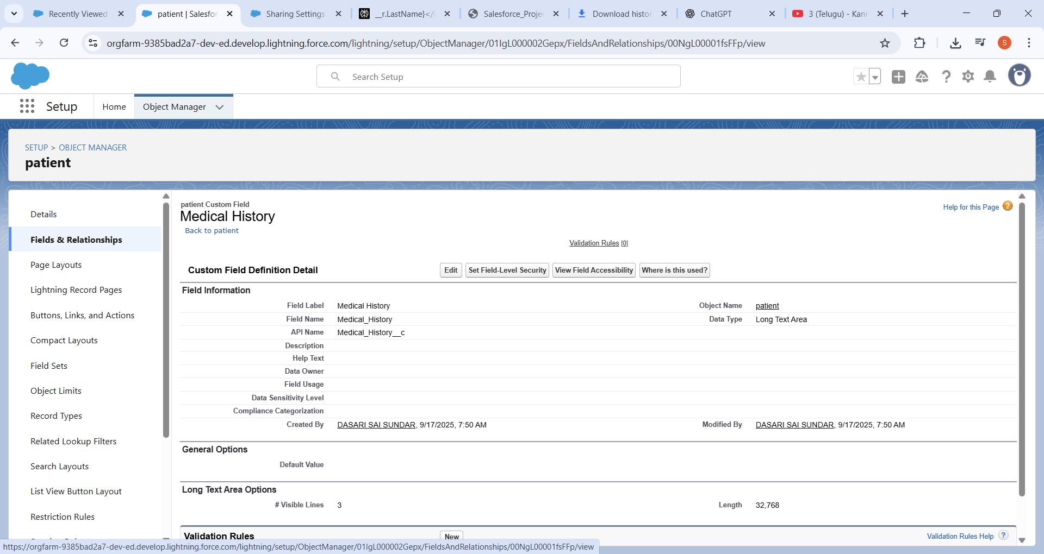

1. Session Settings and Login IP Ranges:
2. Session Settings:

* Under Session Timeout, select your desired idle timeout to one Hour.

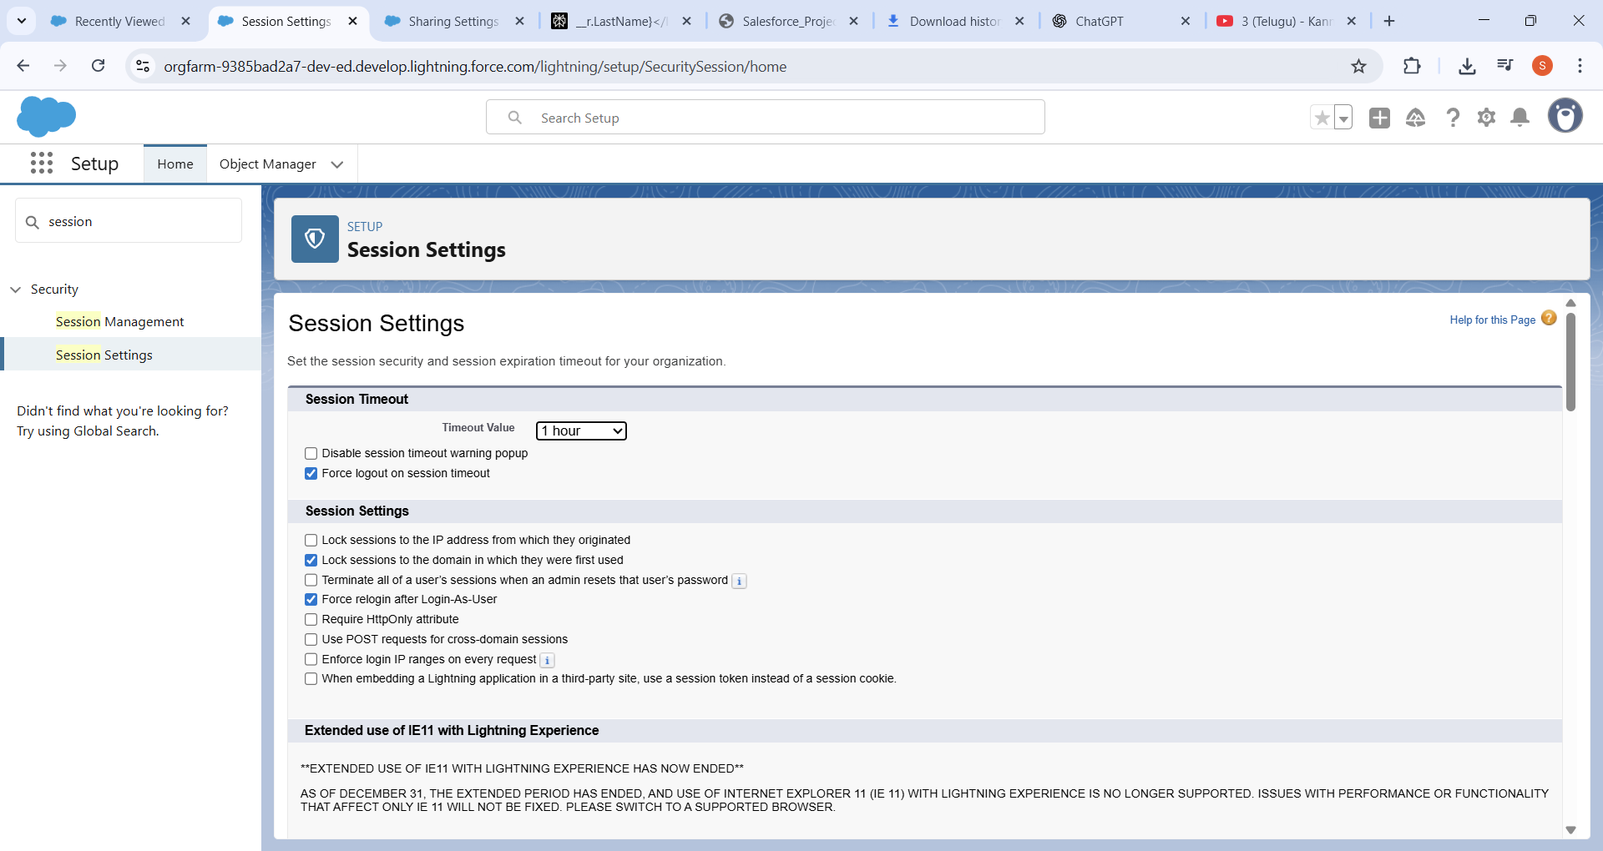

* In the profile settings session timings set to one hour

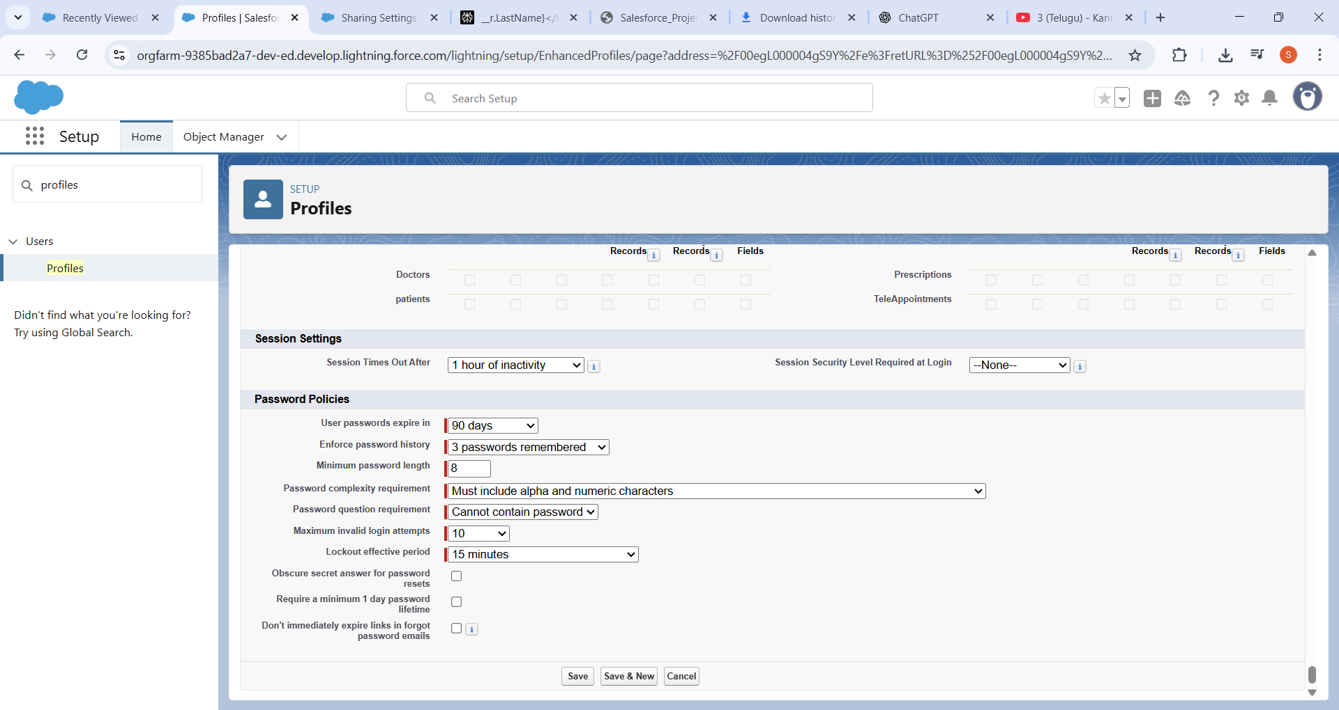

1. Login IP Ranges:

* Enter a Start IP Address and an End IP Address that define your organization’s trusted network  range covers all IP addresses from 103.155.31.0 up to 103.155.31.255.

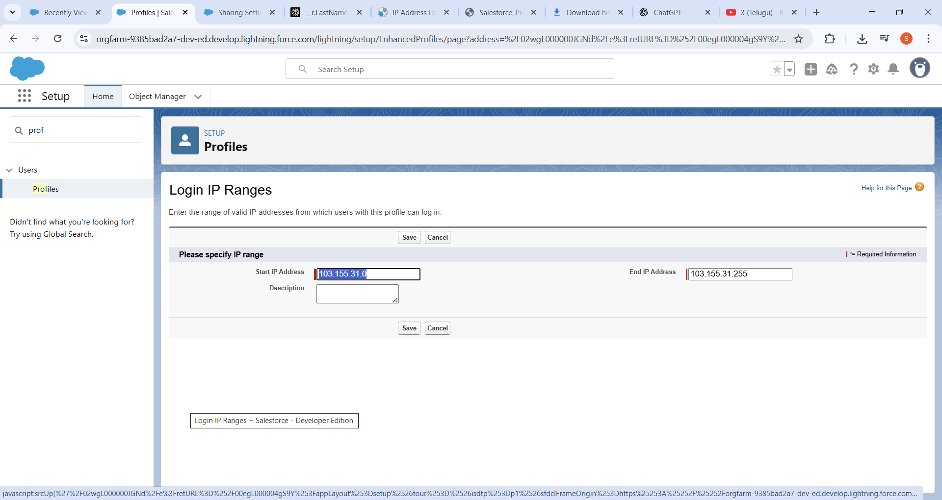

* Testcase1:from my hostel no problem to login

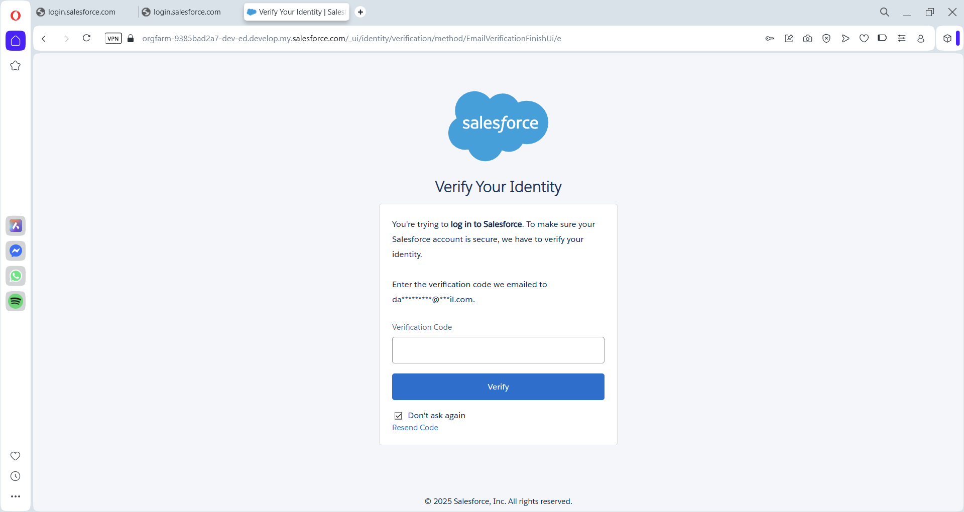

* From my friends home its not opening

